Contents

1 🔧What’s New 2

2 🚀 Fixed Defects 2

3 🚀 Fixed Issues 2

4 Accessibility fixes 2

5 ⭐ Improvements 2

6 🚀 Deployments 3

6.1 CRM 3

6.1.1 CRM Post Deployment Verification 3

6.2 CDN 3

6.3 Web Apps 3

6.4 Platform APIs 3

7 💻 Reviewers 4

8 Appendix 5

8.1 Post Deployment Verification 5

8.2 Running Pipeline from Tags 5

Release Notes

# 🔧What’s New

New user stories delivered: **None**

Logo Rebranding is done for B2B(Marketplace) and Account Portal.

# 🚀 Fixed Defects

The following bugs reported in SIT are addressed in the current interim build –

| **ID** | **Title** | **Severity** | **Priority** |
| --- | --- | --- | --- |
| [35912](https://dev.azure.com/TASMUCP/TASMU%20MSI/_workitems/edit/35912) | FN-Portal-Arabic-While selecting country in Billing Address, countries are not alphabetically sorted | 4 - Low | 2 |
| [35913](https://dev.azure.com/TASMUCP/TASMU%20MSI/_workitems/edit/35913) | NF-Arabic-On order successful page, "Pending" Status is displayed in english, when language selected is Arabic | 3 - Medium | 2 |
| [35932](https://dev.azure.com/TASMUCP/TASMU%20MSI/_workitems/edit/35932) | Main Image source is mapped with thumbnail image | 3 - Medium | 2 |
| [35931](https://dev.azure.com/TASMUCP/TASMU%20MSI/_workitems/edit/35931) | NF-Work Order Arabic Notifications - (Email/Sms) Status is shown in English for Arabic Profile |  |  |

# 🚀 Fixed Issues

The following issues reported are addressed in the current build –

|  |  |  |  |
| --- | --- | --- | --- |
| ID | Type | Title | Priority |
|  | Issue |  |  |

# Accessibility fixes

The following issues related to accessibility have been addressed in this build -

|  |  |
| --- | --- |
| **ID** | **Title** |
|  |  |
|  |  |

# ⭐ Improvements

# 🚀 Deployments

## CRM

|  |  |
| --- | --- |
| **Build Id** | **Pipeline Name** |
| 42658 | [CD-CrmPlatform-Release](https://dev.azure.com/TASMUCP/TASMU%20Central%20Platform/_build/results?buildId=42658&view=results) |

### CRM Post Deployment Verification

* [Verify workflows are activated from deployment guide](https://dev.azure.com/TASMUCP/TASMU%20Central%20Platform/_wiki/wikis/TASMU-Central-Platform.wiki/137/Dynamics-365-Deployment-Guide) (Refer 5.16 section)

6.1.2 Verify the Email Templates are updated with HTML content, if not then import Core solution and while importing select Override the customization.

Email template list is mentioned in 5.17 section of deployment guide.  
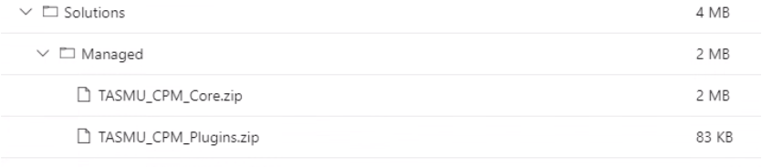

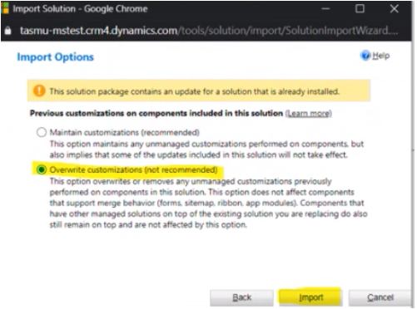

6.1.3 CRM Email Templates Links update

* [Link to be changed in Email templates in CRM and Images needs to be uploaded for Prod](https://dev.azure.com/TASMUCP/TASMU%20Central%20Platform/_wiki/wikis/TASMU-Central-Platform.wiki/137/Dynamics-365-Deployment-Guide?anchor=5.17-email-templates-in-crm-and-images-needs-to-be-uploaded-for-prod) (Refer 5.17 section)

## CDN

|  |  |
| --- | --- |
| **Tag** | **Pipeline Name** |
| SIT_CDN_13May2021 | [CD-CDNContainer-Prd-Release](https://dev.azure.com/TASMUCP/TASMU%20Central%20Platform/_build?definitionId=1019) |

## Web Apps

|  |  |
| --- | --- |
| **Tag** | **Pipeline Name** |
| SIT_Web_13May2021 | [CD-WebApps-Prd-Release](https://dev.azure.com/TASMUCP/TASMU%20Central%20Platform/_build?definitionId=1020) |

## Platform APIs

|  |  |
| --- | --- |
| **Tag** | **Pipeline Name** |
| SIT_API_13May2021 | [CD-PlatformAPIs-Prd-Release](https://dev.azure.com/TASMUCP/TASMU%20Central%20Platform/_build?definitionId=1021) |

# 💻 Reviewers

|  |  |
| --- | --- |
| Prepared By | Manvir Kaur, Sumit Gupta |
| Company name | Microsoft |
| Reviewed by | Ravi Sankar Pillutla, Anil Erkek, Abhishek Ghosh, Subhajit Chatterjee, Gareeb Navas T M, Mecit Atmaca |
| Approved by | Ashwani Sharma |

# Appendix

## Post Deployment Verification

1. Function Apps Running
2. <https://func-cpp-apps-ckan-pre-we-01.azurewebsites.net/>
3. <https://func-cpp-apps-qnasync-pre-we-01.azurewebsites.net/>
4. <https://func-cpp-apps-luistra-pre-we-01.azurewebsites.net/>
5. <https://func-cpp-apps-intbpa-pre-we-01.azurewebsites.net/>
6. <https://func-cpp-apps-intntf-pre-we-01.azurewebsites.net/>
7. <https://func-cpp-apps-pt-pre-we-01.azurewebsites.net/>
8. Marketplace Portal - <https://marketplace.pre.sqcp.qa/en/>
9. Bot – Chat with bot on marketplace
10. My Tasmu Portal - <https://mytasmu.pre.sqcp.qa/en/>
11. Account Portal - <https://account.pre.sqcp.qa/en/>
12. Admin Portal Portal - [https://cpadmin.pre.sqcp.qa](https://cpadmin.pre.sqcp.qa/)  (Login screen should come)
13. API Config access - <https://api.pre.sqcp.qa/config/api/feature>
14. Open Data Portal - <https://opendata.pre.sqcp.qa/>

## Running Pipeline from Tags

